Name: ____________________________ Block_______ Date: ________ Score ______30/pts________%
~Cellular Respiration Yeast Lab~
Bottle A | Bottle B | Bottle C | Bottle D | Bottle E
5 ml sugar | 30 ml sugar | 30ml sugar | 0 ml sugar | 30 ml sugar
2 mL yeast | 2 mL yeast | 5 mL yeast | 2 mL yeast | 0 mL yeast
0 mL salt | 0 mL salt | 5 mL salt | 0 mL salt | 5mL salt
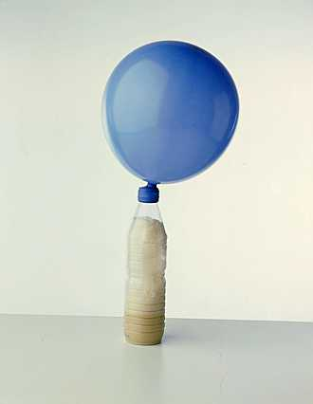

Humans use yeast every day. What is yeast, and what are some common uses of yeast? You can buy yeast to make bread in the grocery store. This yeast consists of little brown grains. Do you think that these little brown grains of yeast are alive? Why or why not?

Scientific Experiment to Test for Metabolism
We will carry out an indirect test for metabolism. In other words, we will be indirectly testing whether yeast can use energy, which is one of the characteristics of living organisms. When yeast, humans, and other living organisms use energy, they break down high-energy molecules like sugar to get the energy they need and give off a gas called carbon dioxide as a by-product of this reaction. We will test whether yeast can metabolize sugar and produce a gas which we will presume is carbon dioxide. Specifically, we will test whether yeast produces a gas when it has sugar available as a food vs. when no sugar is available.

Answer these questions on the back of this sheet:
Be sure to color the balloons the correct colors from the experiment
- Do yeast use energy and produce a gas when sugar is available?
- Do you expect yeast to produce a gas when sugar is available? Why or why not? (2)
- Do you expect yeast to produce a gas when no sugar or other food is available? Why or why not? (2)
- Name the Independent Variable and Dependent Variable for this laboratory exercise. Be specific. (2)
- Name the control for this laboratory exercise.
- What are the constants for this laboratory exercise? (3)
- Make a hypothesis for this experiment. (2)

Analysis Questions to be answered on the back of this sheet:
8. Which balloon was the biggest?
9. Which balloon was the smallest?
10. What is the cellular respiration equation (words only)? (5)
11. When you make bread, if you just mix flour, sugar, and water, the dough does not rise, and the bread will be flat and hard. If you include yeast in the bread dough, then the dough rises and the bread is bigger and fluffier. Can you explain how the yeast helps the bread dough to rise? (2)
12. Explain how this equation just occurred during our investigation of the metabolism of yeast. (4)

Answer Sheet for Yeast Lab
30 points

1. ________________________________________________________________________________________________

2.__________________________________________________________________________________________________________________________________________________________________________________________________

3.__________________________________________________________________________________________________________________________________________________________________________________________________

4. Independent Variable= __________________________________________________
Dependent Variable= __________________________________________________

5. _____________________________________________________

6. _______________________________________________________________________________________________

7. ________________________________________________________________________________________________
__________________________________________________________________________________________________

8. ________________________________

9. __________________________________

10. ______________________________________________________________________________________________

11. _______________________________________________________________________________________________
______________________________________________________________________________________________________________________________________________________________________________________________________________________________________________________________________________________________________
______________________________________________________________________________________________________________________________________________________________________________________________________________________________________________________________________________________________________

12. _______________________________________________________________________________________________
______________________________________________________________________________________________________________________________________________________________________________________________________________________________________________________________________________________________________
______________________________________________________________________________________________________________________________________________________________________________________________________________________________________________________________________________________________________

