Chapter 10 Cell Growth, Division, & Reproduction page 274
SOL.BIO.5afg.7b

Cell size limitations
2 main reasons why cells divide
- The ________________________ a cell becomes the more demands the cell places on its _________
- Larger cells are _________ efficient in moving ______________ and ___________ across the cell membrane
Ratio of surface area to volume
Surface Area: this is the area covered by the ___________________________
How is it calculated? ________________________________________

Volume: the _______________ taken up by the __________________ contents of the cell
How is it calculated? _________________________________________
Practice

Considerations with surface area to volume ratio
Small Cell | Large Cell
- Surface area greater than the volume  - Can get nutrients __________ easily  - Can get wastes _________ easily  - Cytoskeleton only has to transport nutrients __________ distances within cell  - Signal proteins can communicate instructions for cell functions ________________ since only have to travel _____________ distances | - Volume greater than the surface area  - Will have trouble with bringing ___________ in since not as much _________________  - Hard to get all wastes out  - Cytoskeleton has to transport nutrients ______________ distances within cell  - Signal proteins must travel ___________ distances and may not get there in time

_________________________________: the process by which a cell divides into 2 new daughter cells
- Before the cell can divide the _________________ must be copied first
- This solves the issue of having information ________________ since its ______________ cells gets one ____________________ copy of genetic information

2 main types of Cell Division and Reproduction
Asexual Reproduction | Sexual Reproduction
- Used mostly in ______________________ organisms  - Very ____________________  - Efficient  - Populations will _________________ quickly  - Each cell is __________________________________  - When conditions are just perfect, the __________ they can reproduce and increase ____________________  - Disadvantage: ________________________________  ____________________________________________ | - Used mostly in ______________________ organisms  - More ________________________  - Fusion of ______ separate ____________ cells  - Each cell has ___________ of the genetic info from the parent (thus not ______________________)  - Requires more ____________  - Must have __________ & _____________  - Provides _________________ diversity

THE PROCESS OF CELL DIVISION Page 79

______________________________________: Genetic information is bundled into packages of DNA
_____________________________: one of the 2 “sister” parts of a duplicated chromosome
_____________________________: region of a chromosome where the 2 sister chromatids are attached
__________________________ Chromosomes are found in the ________________________
__________________________ Chromosomes do NOT have a _______________________
Found in the __________________
In the shape of a ______________
Go though ______________________________________

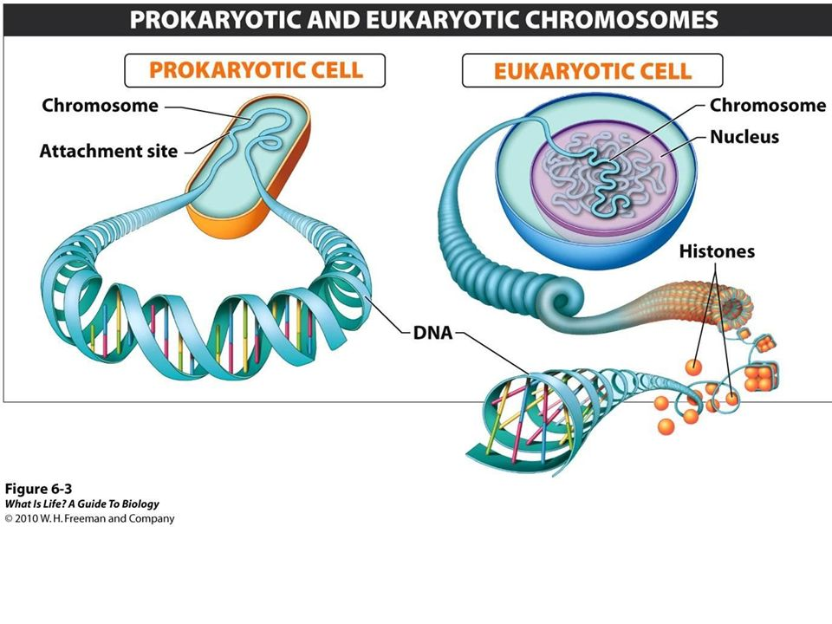

Chromosomes make it possible to ___________________________ DNA precisely during _________ division

THE CELL CYCLE (journal book pic)

Cells reproduce for 2 reasons
________________________________________
________________________________________

There are 3 stages of the Cell Cycle:
- __________________________________: the “in-between” period of growth
Broken into 3 steps
Step #1 ________________ or ______________________________________
Step #2 ________________ or ______________________________________
Step #3 ________________ or _______________________________________
- __________________________________: The division of the nucleus
Broken into 4 steps
Step #1 _______________________
Step #2 _______________________
Step #3 _______________________
Step #4 _______________________
- ________________________________________ : division of the cytoplasm
Stage #1: INTERPHASE (the in-between period of growth)
G1 Phase OR _____________________________: Cell Growth
- Cells do most of their _________________________
- Cells __________________ in size
- Make new _______________________________ and ______________________
S Phase OR _____________________________: DNA Replication
- ______________ is synthesized when the _______________________ are replicated
- The cell at the end of S phase will contain ___________________ as much DNA as it did in the beginning

G2 Phase OR ____________________________: Preparing for Cell Division
- Shortest of the parts of _________________________
- Many of the ___________________________ are produced

Stage #2/3: Mitosis and Cytokinesis

Mitosis: is the _________________________ of the ___________________________
There are 4 parts (PMAT)
PROPHASE
- First phase of mitosis
- This is usually the ________________________________ part of mitosis
- The genetic material in the _____________________ condenses
- The chromosomes (duplicated) are ________________________
- The nucleus and nuclear membrane ___________________________
- Centrioles ____________________
- ___________________ fibers begin to form

METAPHASE

Second phase of mitosis
- This is usually the ____________________ part of mitosis
- The _________________________ of the duplicated ________________________ line up across the center of the cell
- Each ____________________________ is connected to _____________________ fibers at its _______________________________

ANAPHASE
          - Third phase of mitosis
          - The _____________________________________ separate into _________________________ chromosomes and are moved _________________________
          - The individual __________________________ moves along the ____________________ fibers to the opposite end of the cell

TELOPHASE
- Fourth phase of mitosis
- Chromosomes gather at ____________________________ ends of the cell and lose their shape becoming a tangle of _____________________________
- __________________________ membrane _________________ around each cluster of chromosomes
- Spindles fibers ___________________
- Nucleolus becomes visible

STAGE #3: CYTOKINESIS
- Usually occurs at the same time as _____________________________
- __________________________ pinches in ___________________
- Each ____________________________________ cell has an _______________________ set of duplicated chromosomes
- This completes the process of cell division by splitting ____________ cell into _________

Cytokinesis differences
Plant cells: _______________________________________________________________________________________
Animal cells: ___________________________________________________________________________________

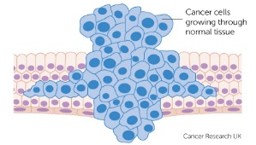
Section 3 Regulating the Cell Cycle
- How does a cell know _______________________ to divide?
  - _____________________ and ___________________ cells do not divide once they have been developed
  - _________________________, _______________________ and digestive tract cells all grow rapidly throughout life
  - ___________________________ regulates the cell cycle
    - These _______________ the cell it is time to go through the cell cycle
    - The cell is controlled by
      - ___________________________ regulators
        - These allow the cell cycle to proceed only when certain events have occurred
inside of the cell
      - ___________________________ regulators
        - Direct the cell to speed up or slow down during the cell cycle
          - Example: ______________________________
            - These stimulate growth and cell division
- Sometimes cells are bad
  - they may die by ____________________________ (in an _______________ or just _______________)
  - they may be _____________________________ to die called ____________________________

CANCER
- a disorder in which body cells _______________________ their ability to __________________ growth
- cancer cells do not respond to the _____________________ that regulate growth
- results in the __________________________________________________
  - this can cause __________________ to form
    - a mass of cell
      - _________________________ tumor
        - These are non-cancerous and do ___________ spread
      - _________________________ tumor
        - These are cancerous and do ______________
        - They invade and destroy the surrounding healthy tissue blocking and preventing
Organs from functioning properly

