**Chemistry Notes Bio.SOL.3 Chapter 2 Page 32**

**MATTER**: is ___________________________________________________________

**ATOMS**: are the _________________________________________________________________

All atoms have the same _________________ of particles. There are 3 different types:

|  |  |  |  |
| --- | --- | --- | --- |
| **Name of Particle** | **Definition** | **Location** | **Charge** |
| 1. |  | nucleus |  |
| 2. |  | nucleus |  |
| 3. |  | Energy cloud |  |
| *What is the nucleus?* |  |  |  |

How to draw the structure of an atom:

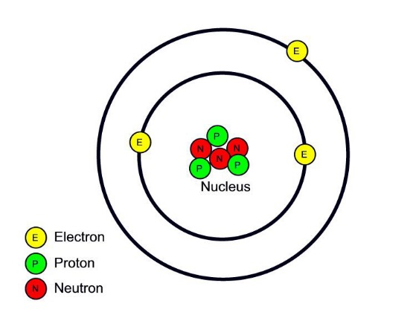

Electrons constantly move around an atom’s __________________ in ___________________________. The basic structure is based on the result of the attraction between _________________________________________________. Atoms contain an _____________ of ____________________ and _________________ so the overall charge of an atom is ____________________.

**Elements**: ________________________________________________________________________________

_________________________________________________________________________________________

Elements are made up of only ___________________________________________________

Each element is represented by a _______________________.

How do you write an element? The first letter is _____________ Second letter is ______________

Examples: _____________________________

**ISOTOPE:** ________________________________________________________________________

How are they identified? ________________________________________________________

Where are these used? __________________________________________________________

**Compound**: _______________________________________________________________________________

__________________________________________________________________________________________

**Examples of compounds include: _______________________________________________________**

**Types of Bonds**

|  |  |
| --- | --- |
| **Covalent Bond** | **Ionic Bond** |
| * e- are __________________ * wants to fill each _______________________ * explain how water (H2O) is a type of covalent bond: * a **molecule** is a compound in which the atoms are held together by covalent bonds   Examples: | * e- are _______________ or _____________________ * ion: _____________________   _________________________   * explain how salt (NaCl) is a type of ionic bond   Examples: |

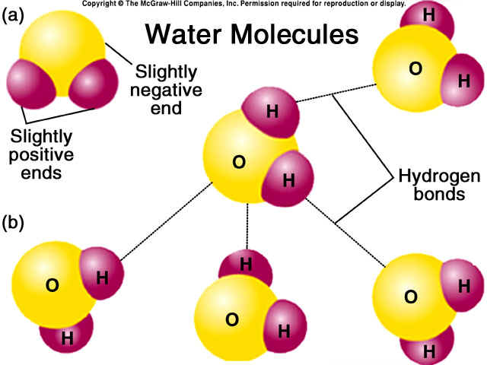

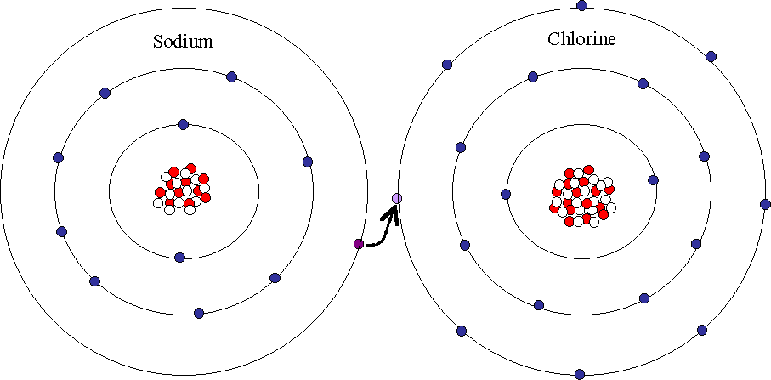

**~~ Chemical Reactions~**

Chemical reactions allow living things to _____________________________________________________

**Chemical Reaction**: ________________________________________________________________________

_________________________________________________________________________________________

**Chemical Equations**

________________________________ 🡪 _____________________________________

___________________________ is the starting substance(s)

___________________________ is the substance(s) formed during the reaction

* means ________________________

**Energy of Reactions:**

The key to starting a chemical reaction is ______________________

**Activation Energy: _______________________________________________________________________**

**________________________________________________________________________________________**

**Enzymes**

All living things are _________________ factories driven by _____________________________. However these chemical reactions proceed very _______________________ when carried out in the lab because the ___________________________________ is _______________. To be useful, additional substances are needed to _____________________ the activation energy to allow the reaction to proceed quickly.

**Catalyst:** _________________________________________________________________________________

**Enzymes**: _________________________________________________________________________________

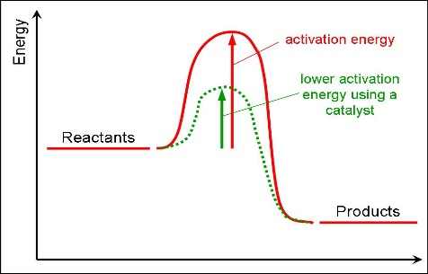 A type of _______________________

Essential to _____________________

An enzymes name describes ________________________________

**Substrate**: ________________________________________________

**Active site**: _______________________________________________

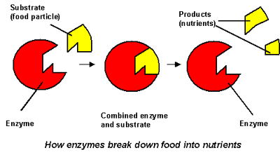

**How an enzyme functions:**

1. _______________ binds to the _____________________ on the enzyme
2. _______________________ changes shape and forms the __________________________________
3. _____________________ reacts to form ____________________
4. The enzyme then releases the _____________

Factors that affect enzyme functioning are ________________ and __________________________

**Section 2- Water and Solutions Page 41**

The properties of _____________ make it well suited to help maintain __________________ in an organism. Water accounts for about ______________ of a cell’s mass. It is one of the most important ________________________ of life.

**WATER PROPERTIES**

[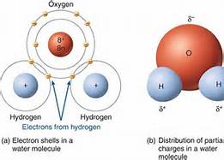](http://www.bing.com/images/search?q=water+covlent+molecule+structure&qs=n&form=QBIR&pq=water+covlent+molecule+structure&sc=0-24&sp=-1&sk=#view=detail&id=DDFFD5D8F9F5DC56BACD584F5971A47D52055A68&selectedIndex=0)

* Water makes a _____________________ type of bond.
* There is a ________________ distribution of electrons
* Oxygen’s end has a _______________ charge
* Hydrogen’s end has a _________________ charge
* Polar molecules: ______________________________

_______________________________________________

* Polarity is the property of having ______ ______________________ poles
* They act like ______________________
* Hydrogen bond: _______________________________

_______________________________________________

**COHESION**

Water molecules are __________________________ to each other

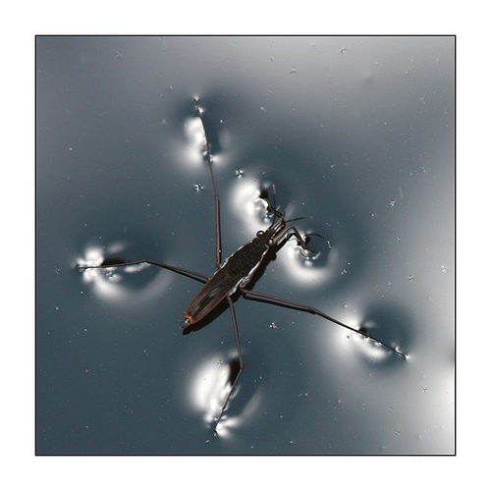This creates ______________________________

Causing water to form ________________

Allows things to ____________________ on water

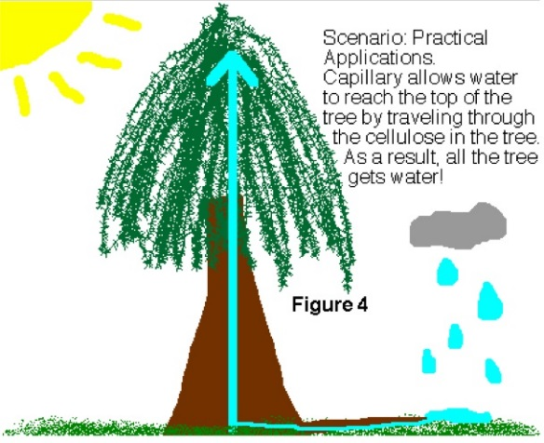**ADHESION**

Forms __________________ with molecules on ____________________ surfaces

This creates _____________________________

Water can __________________ up stems and seeds will swell and germinate

**ACIDS & BASES**

If WATER is broken down it forms ___________________________ & ____________________________

# H2O 🡪 ____________________ + _________________________

|  |  |
| --- | --- |
| **ACIDS**  Will release __________ when dissolved in H2O  Description: http://popsop.ru/wp-content/uploads/amcor_cliffstar_lemon_juice.jpgExamples: | **BASES**  Will release __________ when dissolved in H2O  Description: http://www.savingwithshellie.com/wp-content/uploads/2009/04/ammonia.jpgExamples: |

The measure of concentration of ___________ in a solution is called _______________

**BUFFERS**: ________________________________________________________________

**Section 3 – The Building Blocks of Life Page 45**

Organisms are made up of __________________ molecules

**Organic** means: __________________________________ and must contain ___________

Examples: ____________________________________________________

**Inorganic** means: **__________________________________** and does not contain **___________**

Example: _____________________

**Macromolecule**: _______________________________________________________________________________

**Polymers**: ____________________________________________________________________________________

There are four categories of macromolecules compounds.

1. _________________________________________________
2. _________________________________________________
3. _________________________________________________
4. _________________________________________________

This is the General information about each organic compound (pages )

|  |  |  |  |  |  |
| --- | --- | --- | --- | --- | --- |
| **Organic**  **Molecule** | **Food**  **Source(s)** | **General**  **Purpose** | **Basic building block AKA monomer** | **Elements it contains** | **Structure** |
| **MC900441777[1]CARBOHYDRATE** |  |  |  |  |  |
| **LIPID**  **MC900264252[1]** |  |  |  |  |  |
| **PROTEIN**  **MC900441864[1]** |  |  |  |  |  |
| **NUCLEIC ACID**  MC900088720[1] |  |  |  |  |  |

~Now go back to each section and get a little more detail~

***~CARBOHYDRATES~***

The basic building block is called a ___________________________________

If three or more basic building blocks of carbohydrates bond together it is called a _______________________

Examples include: ____________________________________

**~Lipids~**

Composed of _________________________________________________________________

Function: ____________________________________________________________________

Triglyceride: ________________________________________________________________

Organisms need lipids to function ____________________________________

|  |  |
| --- | --- |
| Saturated Fats | Unsaturated Fats |
|  |  |
|  |  |
|  |  |
|  |  |
|  |  |

**~Proteins~**

What is the building blockof **Proteins? ___________________________________**

|  |  |
| --- | --- |
| **Types of protein** | **Purpose/function** |
|  | Speed up chemical reactions |
|  | Make up structure in your hair/nails/skin |
|  | Transport blood |
|  | Helps fight disease |

When 2 amino acids bond together this creates a _____________________________

Proteins make up _______ of your total body mass and are involved in nearly every ___________ of your body

MC900088720[1]~Nucleic Acids~

What is the basic building block of nucleic acids? ___________________________________

Name the made 3 parts of the basic building block ______________________________

______________________________

______________________________

|  |  |  |
| --- | --- | --- |
| **DNA** | **RNA** | **ATP** |