**Name: ________________________________________ Block: _______**

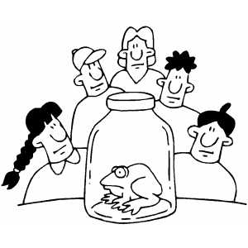**Biology SOL Review**

**I. Scientific Investigation:**

1. Place the following steps of the Scientific Method in chronological order:

|  |  |
| --- | --- |
| _______Communicate your results  _______Construct a hypothesis  _______Analyze data & draw conclusions | _______Ask a question  _______Do background research  _______Test hypothesis (Experiment) |

**Vocabulary: Encyclopedias, Local newspapers, Scientific journals**

2. Research can be conducted using many different sources for current findings.

a. ____________________ are the best place to locate *current* scientific findings.

b. ____________________ are a place to find information on historical theories.

c._____________________ can help research findings about the local environment.

**Vocabulary: Dependent Variable, Hypothesis, Independent Variable, Inference, Observations, Variables**

1. ____________________: Information that is directly gathered using the senses.
2. ____________________: A conclusion you draw based on information.
3. ____________________: An “educated guess” or predicted solution to a problem
4. ____________________: Factors that change and can be measured in the experiment.
5. ____________________: The variable that you change on purpose.
6. ____________________: The variable that changes as a result of changing another variable

**Vocabulary: Constants, Control, Experiment, Qualitative, Quantitative, Variables**

1. ____________________________ is the type of data that is descriptive.
2. ____________________________ is the type of data measured in numbers.
3. ____________________________ are the factors that are measured in an experiment.
4. ____________________________ is the standard condition to compare with results.
5. ____________________________ are the thing(s) that are kept the same in the experiment.
6. ____________________________ is a structured way to test a hypothesis.

**Vocabulary: arm, barrel, base, course focus, diaphragm, eyepiece, fine focus, high objective, medium objective, low objective, lamp, stage clips, stage**



**13.**

**11.**

**12.**

**10.**

**9.**

**8.**

**7.**

**6.**

**5.**

**4.**

**3.**

**2.**

**1.**

The eyepiece magnifies by 10X. What is the total magnification using the 40X objective? ______________________

**II. Characteristics of Living Things**

**Vocabulary: cells, evolution, heredity, homeostasis, interdependence, metabolism, reproduce**

1. **________________________**: Smallest unit of all life
2. **________________________**: Use energy to carry out life functions
3. **________________________**: Organisms rely on each other to survive
4. **________________________**: Produce offspring, either asexually or sexually
5. **________________________**: Maintain a constant internal environment
6. **________________________**: Pass on traits to offspring
7. **________________________**: Populations of organisms change over time

***Biological organization in order from smallest to largest***

**Vocabulary: biosphere, cell, community, ecosystem, organ system, organ, organism, population, species, tissue**

1. ______________________: The smallest unit of life
2. ______________________: Group of cells that carry out a similar function
3. ______________________: Group of tissues that carry out a specialized function
4. ______________________: Group of organs that work together to perform functions
5. ______________________: Single living thing
6. ______________________: Group of the same species that live in the same area
7. ______________________: Group of organisms that can produce fertile offspring
8. ______________________: Group of different species that live in the same habitat
9. ______________________: Community of organisms and their non-living environment
10. ______________________: All of the world and it's atmosphere that support life

**III. Life at the Molecular Level**

***A. Inorganic Compounds*** *(Typically* ***DO NOT*** *contain the element* ***CARBON****)*

**1. Water**

**Vocabulary: adhesion, capillary action, cohesion, density, heat capacity, homeostasis, hydrogen bonding, polar, solvent, surface tension**

* 1. Water molecules have a slightly negative charge at one end and a slightly positive charge at the other end. This means that the molecule is ______________________.
  2. _______________________________________ is the attraction between the positive end of one water molecule and the negative end of another water molecule.
  3. Many of the unique properties of water are caused by **hydrogen bonding:**

1. ___________________________ : Water molecules ‘stick’ to each other
2. ___________________________ : Water molecules ‘stick’ to other things
3. ___________________________ : Movement of water up thin plant tubes
4. ___________________________ : Helps bugs stand on water and water bead up
5. Ice floats because it has a lower ____________________ than liquid water.
6. ___________________________: Water resists temperature change, helping organisms resist temperature changes and maintain ______________________.
7. Called the universal __________________ because it dissolves many substances.

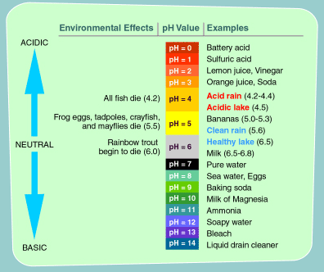**Vocabulary: 0, 7, 14, acids, bases**

The **pH scale** is from **0-14**.

________________ have a

range 0-6.

________________ have a

range 8-14.

Neutral solutions have a pH

of ______.

**2. The Water Cycle**

**Vocabulary: condensation, evaporation, ground water, precipitation, run-off, transpiration**

1. Liquid water changing into water vapor (gas) is called__________________.(#____)
2. Water in the atmosphere forms liquid water in clouds by _____________________. (#____)
3. Water falls to the ground in the form of_____________________________. (#____)
4. Water percolates through the soil to make __________________________. (#____)
5. Water that doesn’t go into the ground is called ______________________ . (#____)
6. Water evaporating from plant leaves is called _________________________(#____)

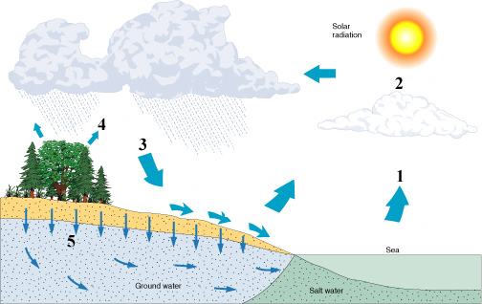

**2**

**6**

**3. The Carbon Dioxide/Oxygen Cycle**

**Vocabulary: autotrophs, chloroplasts, CO2, glucose, heterotrophs, light, mitochondria, O2, photosynthesis, respiration, water**

1. _______________________ are organisms that can make their own food from inorganic compounds.
2. Plants use organelles called _______________________ to collect ____________ energy from the sun in a process called ________________________________.
3. Photosynthesis stores energy for plants in the form of the sugar_______________.
4. Organisms that can’t make their own food are called _______________________.
5. ALL organisms break down food to produce **ATP** in the process _______________, which occurs in the organelle _____________________ in aerobic organisms.

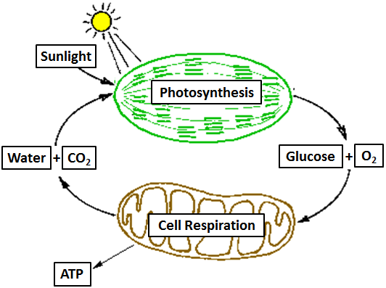

Use the diagram above to write the chemical equation for –

> **photosynthesis**:

> **respiration**:

**4. The Nitrogen Cycle**

**Vocabulary: decompose, denitrifying bacteria, heterotrophs, nitrogen-fixing bacteria, producers**

1. Nitrogen is converted from atmospheric nitrogen into forms that living organisms can use by ______________________________________________.
2. Nitrogen is absorbed from soil bacteria by ___________________ (plants) to build compounds like amino acids.
3. __________________ consume other organisms to obtain nitrogen.
4. When things die the bodies ____________________ and nitrogen goes into the soil.
5. ___________________________________________ convert nitrogen from the soil back into the atmosphere.

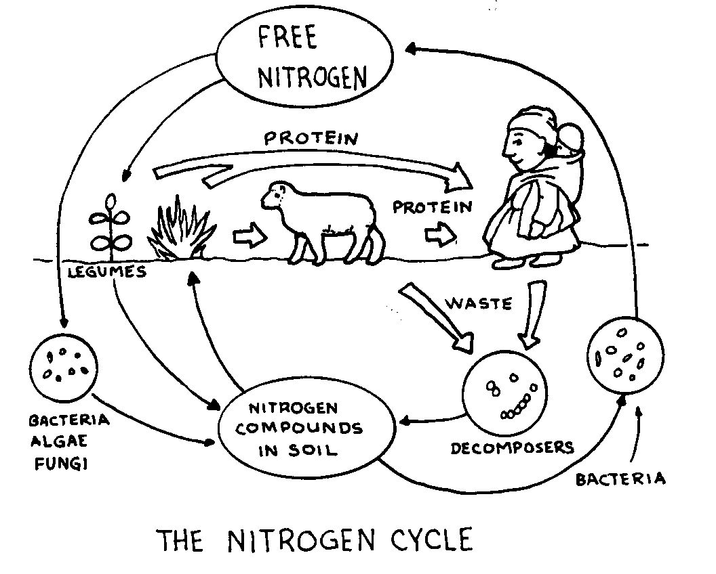

***B. Organic Compounds (Macromolecules)****:* Contain **CARBON**.

1. **Carbohydrates**

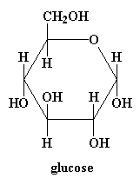**Vocabulary: broken down, built, cellulose, disaccharide, glucose, monosaccharides, polysaccharide**

* 1. Carbohydrates are ________________ to store energy in plants and are __________________________ to be used as cellular energy.
  2. __________________________ are the monomers of carbohydrates.
  3. An example of simple sugar is ____________________________.
  4. Two simple sugars make a _____________________________.
  5. A _________________________ is a carbohydrate made of many sugars.
  6. A polysaccharide found in plant cell walls is __________________________.

1. **Lipids**

**Vocabulary: cuticle, fat, fatty acids, oil, phospholipid bi-layer, store, wax**

* 1. Lipids are macromolecules that are insoluble in water, including ____________, _________________, and __________________.
  2. A monomer of a lipid is made of ____________________________.
  3. Lipids are used to ______________ energy in animals.
  4. Plants have a waxy coating on their leaves called a ____________________ which keeps from losing too much moisture or from becoming water logged.
  5. Cell membranes are made of a ____________________________.

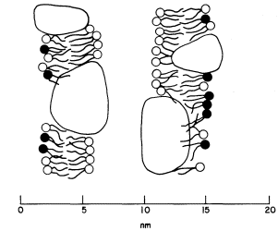

1. **Proteins**

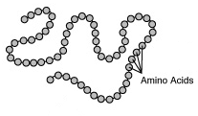**Vocabulary: active site, amino acids, dipeptide, enzymes, gene, peptide, polypeptide, speed up**

* 1. Proteins are made of ______________________ joined by __________________ bonds.
  2. Two amino acids joined together are called a ______________________.
  3. Many amino acids joined are called a _____________________.
  4. The sequence of amino acids for one protein is coded for by one _____________.
  5. ________________ are a special group of proteins that **catalyze** or ____________ ______ reactions.
  6. Enzymes bind to the substrate at the ______________ ____________.

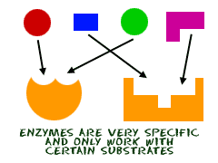

1. 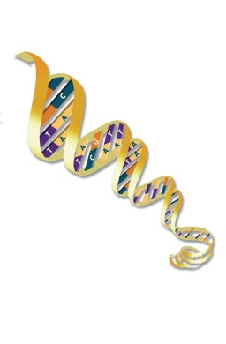**Nucleic Acids**

**Vocabulary: A, C, G, T, U, divides, DNA, double helix, genes, genetic engineering, insulin, nitrogen base, nucleotides, phosphate, proteins, DNA replication, RNA, Rosalind Franklin, sugar, Watson & Crick**

* 1. 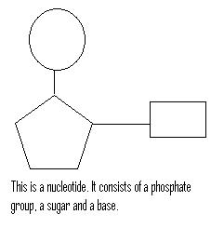The monomer of a nucleic acid is a __________________________, which is made of a ______________________, a ____________________, and a ____________________________.
  2. The two types of nucleic acids are ___________ and ___________.
  3. _________ is common to **all** living things and it stores genetic information.
  4. 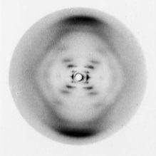In DNA, _____ bonds with_____ and _____ bonds with _____.
  5. The shape of a DNA molecule is a _________________________, discovered by _________________________________.
  6. ______________________________ took an x-ray crystallography image that showed the helical shape of DNA.
  7. _____________________________ is a process that makes an exact copy of DNA before the cell _____________________ into two cells in mitosis.
  8. DNA contains units called ______________ which provide the codes for making _______________________.
  9. ____________________________________ is the process of inserting foreign DNA into host DNA to make recombinant DNA to make proteins like _________________________, interferon, and human growth hormone.

Compare and contrast DNA and RNA by filling in the chart:

**Vocabulary: 1, 2, A-C-T-G, A-C-U-G, deoxyribose, ribose**

|  |  |  |
| --- | --- | --- |
|  | **DNA** | **RNA** |
| # of strands |  |  |
| Nitrogen bases (A,C,T,G,U?) |  |  |
| Sugar |  |  |

**IV. Life at the Cellular Level**

***A. The Parts of the Cell Theory***

1. ____________________________________________________________________

____________________________________________________________________.

1. ____________________________________________________________________

____________________________________________________________________.

1. ____________________________________________________________________

____________________________________________________________________.

***The modern cell theory adds 4 additional parts to the cell theory:***

**Vocabulary: DNA, independent, metabolism, species**

1. The activity of an organism depends on the activity of ___________________ cells.
2. Energy flow (_______________________ and biochemistry) occurs within cells.
3. Cells contain ____________ which is found specifically in the chromosome..
4. All cells are basically the same in chemical composition in organisms of the same _______________________.

***B. Development of the Cell Theory***

**Vocabulary: Hooke, Leeuwenhoek, Pasteur, Redi, Schleiden, Schwann, Virchow, spontaneous generation,**

1. __________________________: Observed cells in pond water through his own invention. He made the 1st microscopes that could see bacterial cells!
2. __________________________: Observed cork and named cells
3. __________________________: Studied plant cells
4. __________________________: Studied animal cells
5. __________________________: Proposed/concluded that all cells come from preexisting cells
6. __________________________: Performed a meat/maggot experiment to disprove the idea that living things come from nonliving matter, which is called _______________________ ______________________.
7. __________________________: Performed an experiment with meat broth in a swan neck flask to disprove spontaneous generation

***C. Types of Cells***

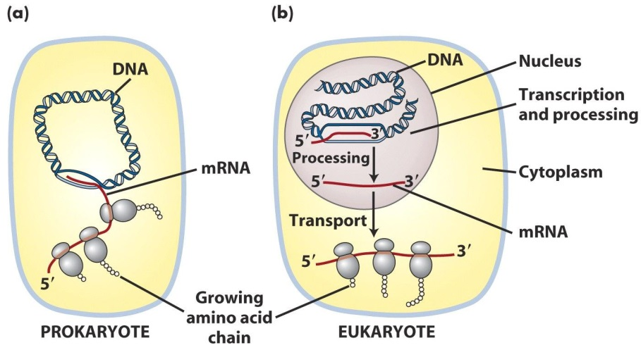

**Vocabulary: prokaryotes (P), eukaryotes (E), both (B)**

|  |  |
| --- | --- |
| 1. _____- have a nucleus 2. _____- have membrane-bound organelles (ER, Golgi, Vacuoles…) 3. _____- go through mitosis 4. _____- go through binary fission 5. _____- have ribosomes to synthesize proteins 6. _____- domains Archaea and Bacteria. | 1. _____- kingdoms Protista, Fungi, Plant, and Animal 2. _____- do not have organized structures within the cell, except ribosomes 3. _____- have DNA, (HINT: ALL kingdoms of organisms have this in common) |

***D. Differences between plant and animal cells*** (complete the table)

|  |  |  |
| --- | --- | --- |
| DIFFERENCES | Plants | Animals |
| 1. Shape |  |  |
| 2. **Different** organelles present |  |  |
| 3. Outside covering. |  |  |

***E. Cellular Organelles***

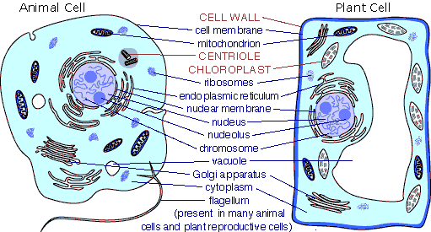

***Use the organelles listed above as a word bank – organelles may be used more than once.***

1. _____________________- location of DNA in the form of chromosomes
2. _____________________- the jelly-like fluid in which reactions occur inside a cell
3. _____________________- small organelle in the nucleus that makes ribosomes.
4. _____________________ - small spheres in the cytoplasm and on the rough ER
5. _____________________ - transport system of the cell
6. _____________________- collects, packages, and distributes proteins
7. _____________________- the organelle that assembles protein
8. _____________________- contains digestive enzymes to break down old cell parts
9. _____________________- storage tank of the cell
10. _____________________- organelle that conducts respiration for the cell
11. _____________________- organelle that conducts photosynthesis for plant cells
12. _____________________- the ‘powerhouse’ of the cell
13. _____________________ - the outer layer or boundary of an animal cell
14. _____________________- rigid boundary made of cellulose (plants) or chitin (fungi)
15. _____________________ - would be quite numerous in an active heart muscle cell (requires a lot of energy)
16. _____________________ - would be numerous in a pancreatic cell that produces large quantities of the protein insulin.

***F. The Fluid Mosaic Model and Movement through the Cell Membrane***

**Vocabulary: active, diffusion, charge, endocytosis, energy, exocytosis, facilitated, high, large, low, osmosis, passive, phagocytosis, phospholipids, pinocytosis, proteins, water**

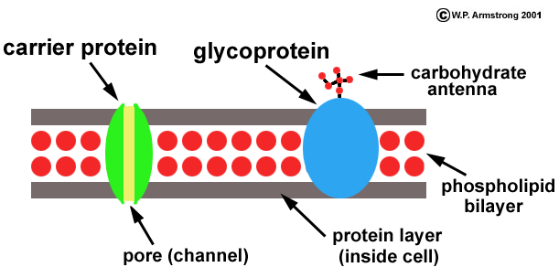

1. The cell membrane is composed primarily of _________________________.
2. _________________ transport doesn’t require energy because it moves molecules from areas of ____________ concentration to _____________ concentration.
3. Movement of molecules across the membrane is called ____________________.
4. Molecules that are too ___________ or have too much of a ____________ cannot diffuse through the membrane so they move through transport ______________.
5. _____________________ diffusion is the type of passive transport that uses carrier proteins to help molecules move across the membrane.
6. ____________________ is the diffusion of water molecules through a membrane.
7. _________________ transport requires energy because it moves molecules from areas of ____________ concentration to _____________ concentration.
8. Membrane folding that takes in particles is called __________________________.
9. Membrane folding that expels materials from the cell is called ________________.
10. Endocytosis that takes in solid particles is called _________________________.
11. Endocytosis that takes in liquid is called _________________________.

***G. Surface Area to Volume Ratio***

**Vocabulary: large, surface-area-to-volume, surface area, volume**

1. There is a limit to how __________ a cell can be because of the ___________ _____________ _____ ______________ ratio.
2. As the size increases, the _____________ increases faster than the ____________ _____________ so there is not enough membrane space for materials to diffuse in and out of the large cell.

**V. Cell Division**

***A. Mitosis***

**Vocabulary: anaphase, centrioles, centromere, copied, cytokinesis, furrow, interphase, metaphase, nucleus, plate, prophase, sister chromatids, spindle fibers, telophase**

1. DNA is __________________________ before mitosis during ____________________ so each cell will have the same DNA.
2. During ________________________ the nuclear membrane begins to disappear and chromosomes condense and become visible under a microscope.
3. Chromosomes line up along the equator of the cell in __________________________.
4. During _____________________ sister chromatids are separated and pulled to opposite ends of the cell.
5. In __________________________ new nuclear membranes begin to form around each set of chromosomes
6. After the nucleus divides, _______________________, or division of the cytoplasm, occurs.
7. In plant cells only, a cell ________________________ forms during cytokinesis.
8. In animal cells only, a cell ___________________________ forms during cytokinesis.
9. A duplicated chromosome in mitosis is made of two identical parts called ____________ __________________.
10. The parts of a chromosome are held together by a _________________________.
11. Only animal cells have ____________________ to help with chromosome movement.
12. ____________________________ are attached to chromosomes at the centromere and pull the chromosomes apart during anaphase.

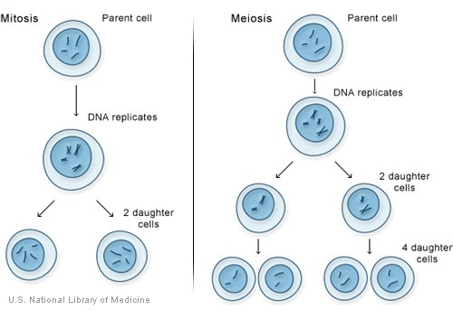

***B. Meiosis.***

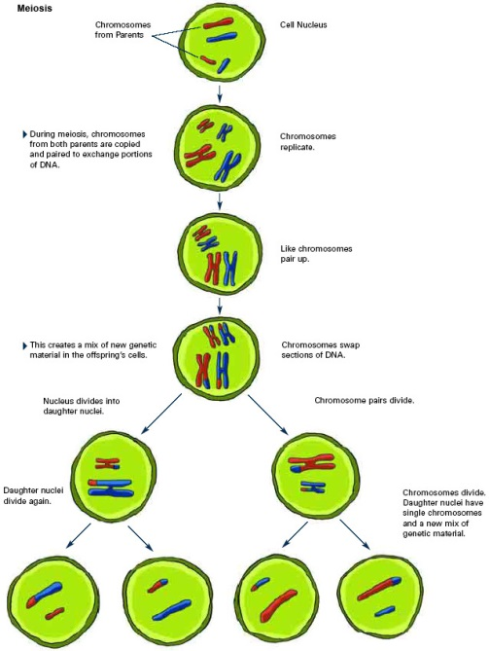**Vocabulary: 1, 2, 23, 46, crossing over, diploid, eggs, gametes, half, haploid, homologous, sperm**

1. Meiosis is a type of cell division that makes sex cells or _________________________.
2. The two types of sex cells are ___________ and _____________.
3. A human’s body cells have ________ chromosomes; sex cells have ________.
4. For every chromosome your mother gave you, there is a ______________________ chromosome from your father with information about the same trait(s).
5. The cell is said to be ______________ when a cell has one homologous chromosome from each parent (2 copies of each)
6. Sex cells are ___________________ because they have only ONE member of each pair of homologous chromosomes.
7. Chromosomes exchange genetic information during _______________ ___________ which adds to diversity.

|  |  |  |
| --- | --- | --- |
|  | **Mitosis** | **Meiosis** |
| # of cells produced |  |  |
| Haploid or diploid? |  |  |
| # of chromosomes in daughter cells |  |  |
| Body cells or sex cells? |  |  |
| Identical or different genes? |  |  |

***C. Other types of division in Organisms***

**Vocabulary: binary fission, budding**

1. ______________________________________- only occurs in prokaryotes
2. ____________________________- occurs in yeast and hydra when a tiny bud sprouts from a parent

***D. Making a Protein***

**Vocabulary: amino acids, anticodons, codon, cytoplasm, diffusion, DNA, mRNA, nitrogen bases, nucleus, peptide, protein, ribosome, transcription, translation, tRNA,**

1. The ______________________________ (A, T, G & C) are the parts of the nucleotide that carries the genetic code.
2. The process of protein synthesis is broken into two stages: _____________________ and ________________________.
3. During transcription the genetic code is copied from ___________ to __________.
4. Because DNA can’t leave the ________________________, the message is carried out to the cytoplasm by ____________.
5. A sequence of 3 bases on DNA or mRNA is called a(n) _________________ ; the 3 complementary bases on tRNA are called a(n) ___________________.
6. Each codon codes for one specific _______________ ______________, which are carried to the ribosome by _____________ molecules and put together to make a protein.
7. Amino acids are linked by ______________ bonds to form a _________________.
8. Using the mRNA sequence to create a protein is called ____________________.

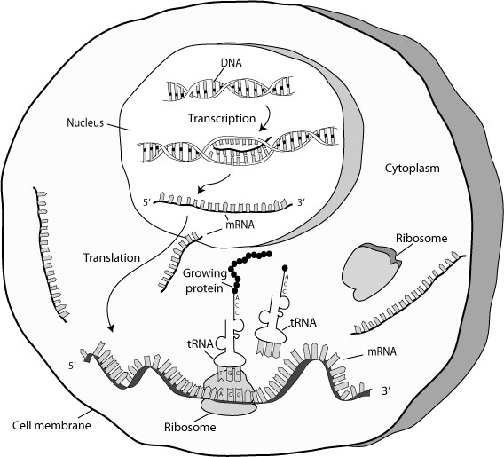

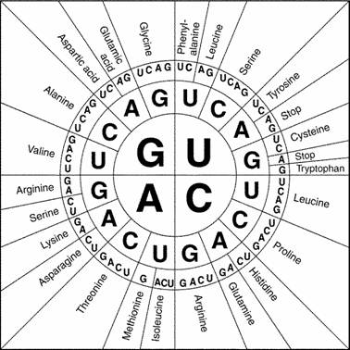***E. Transcription and Translation:***

*Use the codon chart to transcribe and translate the following DNA sequence.*

DNA STRAND: T A C G G C C A T T T C G A T T T G A G C A T C

1. mRNA _________________________________________________________________

2. amino acids: ____________________________________________________________

_________________________________________________________________________

***F. DNA Technology***

**Vocabulary: diseases, DNA fingerprinting, identical, fraternal, gene sequence**

1. _____________________________ is used to identity crime suspects (such as murder).
2. Using electrophoresis, scientists can determine an individual’s DNA fingerprint. No 2 people have the same profile, except for _________________________ twins.
3. The Human Genome Project was a collaborative effort because 13 countries worked on it. Their objective was to understand the _______________ ____________________ of the human genome in order to find the causes of _____________________________.
4. Look at the electrophoresis to the right.

**Dad 1**

**Mom**

**Baby**



**Dad 2**

Who is the father of the child?

________________________

**[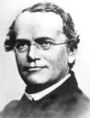](http://images.google.com/imgres?imgurl=http://history.nih.gov/exhibits/nirenberg/images/photos/01_mendel_pu.jpg&imgrefurl=http://history.nih.gov/exhibits/nirenberg/popup_htm/01_mendel.htm&h=524&w=400&sz=32&tbnid=vQfLo8opbQ_SgM:&tbnh=129&tbnw=98&hl=en&start=3&prev=/images?q=gregor+mendel&svnum=10&hl=en&lr=&safe=)VI. Genetics**

***A. Genetics Basics***

**Vocabulary: alleles, dominant, gene, genome, genotype, Gregor Mendel, heredity, heterozygous, homozygous, phenotype, recessive, trait**

1. ____________________________ is the Father of Modern Genetics.
2. ____________________________ is an inherited characteristic.
3. ____________________________ is a segment of DNA located on a chromosome those codes for one protein or trait.
4. ____________________________ are different forms of one gene (ex – tall v. short)
5. ____________________________allele that always shows even in the presence of recessive allele.
6. ____________________________allele that is **only** expressed when homozygous.
7. ____________________________ means two **different** alleles, a hybrid (Tt)
8. ____________________________means two alleles of the **same** form that make up a genotype, pure breed (TT or tt)
9. ____________________________ is the **genes** an organism has for a trait.
10. ____________________________ is an organism’s **physical** appearance for a trait.
11. ____________________________is all of the genes in an organism.
12. ____________________________ is the passing of characteristics from parent to offspring.

***In pea plants green is dominant over recessive yellow color. Fill out the table below:***

**Genotype Genotype Symbols Phenotype**

Homozygous Dominant ___________ _____________________

Heterozygous ___________ _____________________

Homozygous Recessive ___________ _____________________

***B. Genetic Crosses***

**Vocabulary: codominance, dihybrid, F1, F2, P, incomplete dominance, independent assortment, monohybrid, Punnett square, segregation, sex-linked**

1. _______________________is used to diagram the probability of offspring genotypes
2. A _________________________ cross constitutes a study of only **one** trait
3. A_________________________ cross constitutes a study of **two** traits at a time
4. The first generation of a cross is the _______or parental generation
5. The offspring of the P generation is the _______ generation.
6. The offspring of theF1 generation is the _______ generation.
7. The Law of ________________________ __________________________ states that each gene is inherited separately from others if they are on different chromosomes.
8. The Law of_____________________________________ states the 2 alleles for each trait separate as gametes form.
9. _________________________ _________________________is blending of traits; *red flowers + white flowers = pink*
10. In _________________________________ both alleles are expressed equally, as in *blood typing (A+B = AB).*
11. _________________________ traits are controlled by genes on sex chromosomes; for example *colorblindness* or *hemophilia*

***Green color (G) is dominant to yellow color (g). Two heterozygous green peas are crossed. Show the cross below:***

|  |  |
| --- | --- |
|  | *peas* |
|  |  |

Genotypic ratio is ______GG :______ Gg :______ gg

Phenotypic ratio of _______green :_______ yellow.

***A family pedigree for albinism is shown below. Albino individuals lack all pigmentation so that their hair and skin are white.***

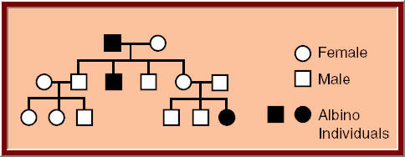

1. Based on the pedigree, is albinism recessive or dominant? ____________________
2. What can you determine about non-albino parents of an individual with albinism? _________________________________________________________________

***C. Mutations****~ there are 2 major types ‘****gene’*** *and ‘****chromosomal’***

**1. Gene Mutations**

**Vocabulary: point, frame shift, mutagens, nucleotide**

1. A gene mutation is a change in one or more ____________________ bases of DNA.
2. Mutations are caused by _______________ like chemicals or UV light.
3. A _____________________ mutation is when 1 nucleotide base in DNA is changed to another.
4. A _____________________ mutation occurs if 1 or more nucleotides in DNA are added or deleted; this causes the codon sequence to be shifted.

**2. Chromosomal Mutations**

**Vocabulary: deletion, duplication, haploid, inversion, nondisjunction, translocation**

* 1. _____________________ occurs when chromosomes don’t separate during meiosis
  2. ______________________: chromosome pieces are moved to another chromosome
  3. ________________________: a segment of chromosome is inserted in reverse order
  4. ________________________: a segment of a chromosome is repeated
  5. ________________________: a segment of a chromosome is removed

***D. Genetic Disorders***

**Vocabulary: 21st, 23rd, karyotype, monosomy, nondisjunction, trisomy, XX, XY**

1. Only a ________________________ detects a chromosomal mutation
2. Down Syndrome is ____________________ on the _________ chromosome pair.
3. 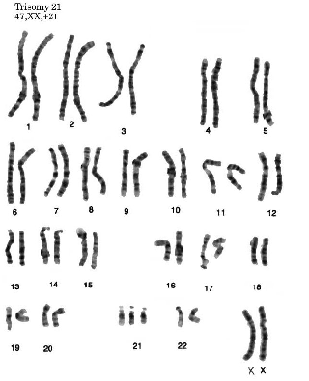Females have the chromosome pair ________, while males have __________.

**Disorder:**

**______________________**

**Gender:**

**______________________**

**VII. Taxonomy -** the naming and organization of organisms developed by **Carolus Linneaus,** based on structural similarities

***A. Classification****:*

Complete the table by arranging the terms largest (1) to smallest (7)

**Vocabulary: Class, Domain, Family, Genus, Kingdom, Order, Phylum, Species**

1. **__________________________**
2. **__________________________**
3. **__________________________**
4. **__________________________**
5. **__________________________**
6. **__________________________**
7. **__________________________**
8. **__________________________**

***B. Naming Organisms***

**Vocabulary*:* binomial nomenclature, different, genus, kingdom, Linnaeus, species, the same**

1. ___________________ ________________________ is the ‘2 name naming’ system that was developed by ________________________ to classify organisms.
2. An organism’s scientific name is its _____________ and _________________ (eg - *Homo sapiens*)
3. If 2 organisms are in the same genus, they must be in ____________________ family
4. *Clostridium tetani* and *Clostridium botulinum* are two types of bacteria from _____________________ species, but they are in ______________________ genus
5. Only organisms that interbreed and produce fertile offspring are in the same ________________________.

***C. Kingdoms***

**Vocabulary: cell membrane, cell wall, eukaryote, prokaryote, unicellular, multicellular, autotroph, heterotroph, algae, dogwood tree, jellyfish, moss, mushroom, sponge, streptococcus, yeast**

|  |  |  |  |  |  |
| --- | --- | --- | --- | --- | --- |
| Kingdom | Prokaryote or Eukaryote? | Cell Wall Present or Absent? | Unicellular or Multicellular? | Autotroph or Heterotroph? | Examples |
| **Archea** |  |  |  | **both** | **extreme organisms** |
| **Bacteria** |  |  | **both** |  |
| **Protista** |  | **varies** | **both, usually unicellular** | **Both** | **Paramecium** |
| **Fungi** | **wall made of chitin** | **both** |  |  |
| **Plantae** | **wall made of cellulose** |  |  |  |
| **Animalia** |  |  |  |  |

***D. Viruses, agents of disease***

**Vocabulary: against, antibodies, cell, host, living, nonliving, nucleic acids, protein, virus**

1. 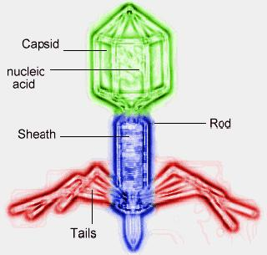Viruses are considered _______________________ because they cannot perform the characteristics of life without a ____________________.
2. Viruses are made of 2 organic compounds:
   * + _______________ ______________ (*DNA/RNA*)
     + a __________________________ coat (*capsid*)
3. A virus infects a cell by injecting its ____________________________ into a cell.
4. The cold and the flu are caused by a ________________________.
5. Antibiotics are typically used to fight bacterial infections. “Antibiotic” means _________________ life. Because viruses are ___________________________, antibiotics don’t work against viruses.
6. Vaccines are used to help organisms make ______________________________ to build immunity. Vaccines are made from weakened ____________________.

***F. Sexual Reproduction in Plants***

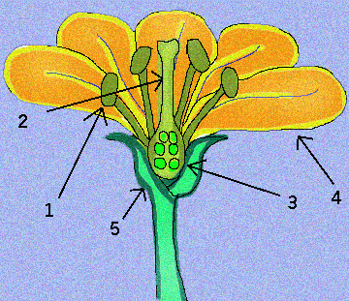**Vocabulary: birds, eggs, insects, pistil, plants, running water, sexual, stamen, wind**

1. Animals and __________________ use ____________________ reproduction.
2. Pollen is located on the tip of the _____________________ (**# ______**), which is the male part of a flower.
3. Ovules are the same things as ____________.
4. The female part of a flower is called the ______________________ (**# ______**)
5. For fertilization to occur, plants rely on animals like ______________________ and __________________, as well as ___________________ and _________________ _______________________ to transport pollen.

**VIII. Evolution – theory** that organisms change in genes and characteristics over time.

***A. Early Theorists***

**1. Lamarck**

**Vocabulary: Inheritance of Acquired Traits, Law of Use and Disuse**

1. ___________________________________________ : if you don’t use it, you lose it
2. Lamarck believed that giraffe’s long necks were a result of being stretched because they were trying to reach tall trees and passed on these stretched necks to offspring.
3. __________________________________________________ was his belief that if a change occurs and is beneficial to an organism’s survival, then it will be passed on; ex. if a toe gets cut off and it’s helpful, then that trait gets passed on to offspring.
4. **NO fossil evidence** to support this theory so it was ***thrown out.***

**2. Charles** **Darwin**

**Vocabulary: finches, Galapagos, Natural Selection, Survival of the Fittest, On the Origin of Species**

1. Darwin’s theory was called _____________________ _____________________.
2. __________________________________________ : only the organisms that are best suited to their environments will survive.
3. The ___________________________________ are islands in South America. The _______________ on them had adapted beaks for the food source on each island.
4. __________________________________________________ was Darwin’s book that compiled his evidence for evolution.

***B. Types and Rates of Evolution***

**Vocabulary: convergent, divergent, gradualism, punctuated equilibrium**

1. ________________________________ : related organisms become more distant (finches with different beaks)
2. ________________________________ : distantly related organisms develop similar characteristics
3. ________________________________ : organisms evolve as a result of small adaptive changes over time
4. _____________________________________________: long periods of no change followed by short periods of rapid change.

***C. Evidence of Common Ancestry***

**Vocabulary: appendix, common ancestors, DNA sequence, embryology, fish, gorillas, homologous structures, older, rabbits, radioactive, vestigial structures, younger**

1. ___________________ _____________________: a bat’s wing, whale’s flipper, and human arm have the same number, type, and arrangement of bones.
2. The presence of the same number & type of bones in the wing of a bat and the arm and hand of a human suggests that a bat and a human must share ____________________ ___________________________.
3. 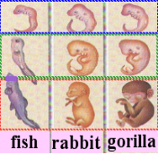Finding the _________ ______________________ or the amino acid sequences is the most specific way to compare organisms and provide evidence of common ancestry.
4. __________________________________: embryos of different organisms (chicken, human, rabbit) look similar at certain early stages, which mean the same genes are being expressed at those times.
5. According to the diagram to the right, the __________________________________ and ________________________ are more closely related because they look alike.
6. ____________________ _____________________ are structures that have no use today, but may have been useful in ancestors. The ____________________ in humans may be a remnant of a digestive organ found in other organisms.
7. According to relative dating of fossils: the deeper underground the fossil is the ___________________________ it is.
8. To find the precise age of a fossil, _______________________________ dating can be used.

**IX. Ecology** - the study of organisms and their interactions with the environment

***A. Biomes and Ecosystems***

**Vocabulary: climax community, ecological succession, pioneer species, primary succession, secondary succession**

1. The predictable and gradual replacement of species over time is called ____________________________ _________________________.
2. The first organisms to colonize an area like lichen, mosses, small shrubs and plants are called ____________________ ______________.
3. Fires that destroy climax communities can occur naturally in forests if, for instance, lightning strikes trees or dry foliage. This can help an ecosystem by allowing succession to start over. This would be categorized as

_______________________ ___________________________.



1. The diagram to above shows the stages of primary succession. Place the letters

(W-Z) in order of occurrence: ________ > _________ > ________ > _________

1. Hardwood trees and large plants are associated with the end stage of succession

called a _______________________ ______________________ This would be letter ________.

***B. Energy Transfer***

**Vocabulary: abiotic, autotrophic, biosphere, biotic, carnivore, community, consumer, decomposers, decrease, ecosystem, energy, herbivore, heterotrophic, increase, omnivore, population, producer, scavengers**

1. A ____________________ is an organism at the beginning of a food chain.
2. Organisms, like plants, that can make their own food are ______________________.
3. Organisms that feed off of other organisms are ______________________________.
4. A ________________________ is an organism that eats producers or other organisms for energy.
5. A nonliving part of the environment is a(n) ________________________ factor.
6. A living part of the environment is a (n) ________________________ factor.
7. A consumer that eats only producers is called a (n) ________________________.
8. A consumer that eats both plants and animals is called a (n) ____________________.
9. A species that lives together and interbreeds is a(n) ________________________.
10. Many populations of different organisms living together is a(n) _________________.
11. The organisms in an area plus the abiotic factors is a(n) _______________________.
12. The Earth represents a(n) ________________________.
13. ________________________ is transferred through an ecosystem by eating or consuming food.
14. ________________________ eat things that are already dead (ex. vulture)
15. ________________________ break down decaying organisms and nutrients are put back into the soil by bacteria and fungi like mushrooms)

[A hunter <---- a fox <---- a rabbit <---- grass]

1. In this food chain, the rabbit is a __________________, the fox is a __________________, and the grass is a ___________________
2. In this food chain, if the rabbit population increased, then the fox population would probably ____________________________. This would cause an eventual _________________ in the population of rabbits.

***C. Relationships***

**Vocabulary: commensalism, mutualism, parasitism, symbiosis, water, predation, sunlight, extinction, limiting factors, competition for food, pollution, disease, climate**

1. ________________________: organisms in very close ecological relationships.
2. ________________________: one organism is harmed while the other benefits
3. ________________________: both organisms benefit.
4. ________________________: one organism benefits and the other is unaffected.
5. ________________________: Example would be a flea and a cat.
6. Anemones release poisonous chemicals from their tentacles that paralyze prey. Clown fish are not affected by the poison & find protection from predators by living near anemones. This is called ___________________________ because the fish benefits but doesn’t affect the anemone at all.
7. Lichen is a type of symbiosis in which a type of algae and fungus live together. This type of relationship is called ________________________________.
8. Things that restrict the size of populations are called _________________________ ________________________.
9. On the rain forest floor, a limiting factor for plants would be __________________.
10. In the desert, a limiting factor for both plants and animals would be _____________.
11. Hunting is encouraged for deer populations because they live in such close proximity to each other that spreading harmful _______________________ is a limiting factor.
12. Only 3,000 manatee *Trichechus manatus* are left, and most of them are in the ocean around Florida. Because there is little genetic diversity, a disease that reduces fertility might cause _______________________________.

**Schedule of Packet Due Dates:**

|  |  |  |
| --- | --- | --- |
| **Due Date** | **Page Due** | **Teacher Initials for Completion** |
|  | **1** |  |
|  | **2** |  |
|  | **3** |  |
|  | **4** |  |
|  | **5** |  |
|  | **6** |  |
|  | **7** |  |
|  | **8** |  |
|  | **9** |  |
|  | **10** |  |
|  | **11** |  |
|  | **12** |  |
|  | **13** |  |
|  | **14** |  |
| **December 5th – Biology SOL** | | |